 **Bulat**

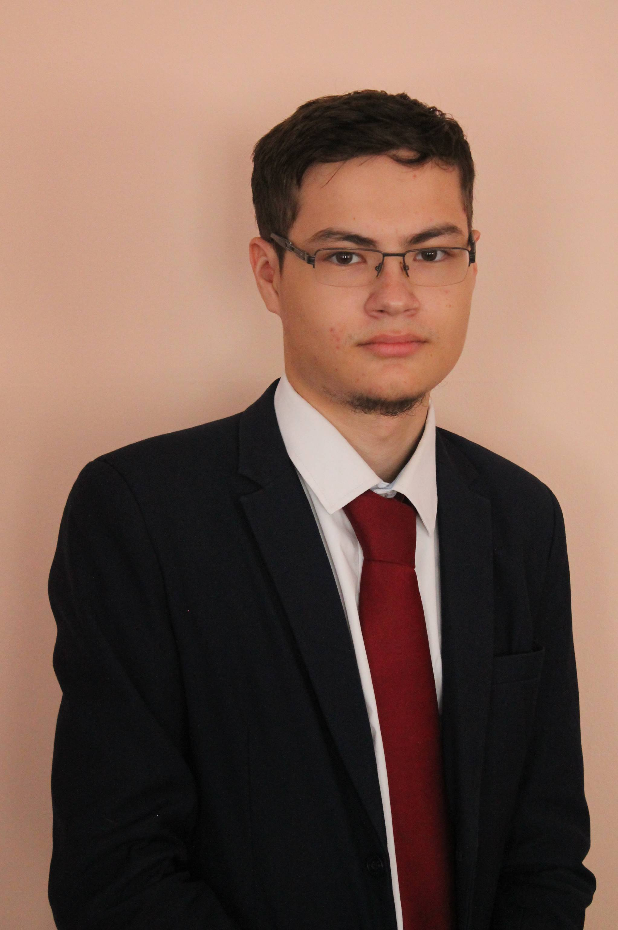

**Nasyrov**

BACK-END DEVELOPER

[***GitHub***](https://github.com/David2261/)[***Telegram***](https://t.me/Suleiman_1) [***LinkedIn***](https://www.linkedin.com/in/bulat-nasyrov-7705231bb)[***Twitter***](https://twitter.com/ad_ge_1?t=f7e9A6fqx-D3i7cGnaRgog&s=03)

*Looking for interesting challenges*

About me:

I'm a back-end web developer. I improve my skills and expand them by learning new technologies. I have experience in creating CBV, using Python/Django, React/JS, HTML, CSS/SASS.

I devote my free time to programming, code tricks and walks around the city. I’m also learning how to program a PLC using the TIA Portal.

***WORK EXPERIENCE***

*Freelance, back-end developer* (2021, June)

Back-end Developer using Django/React, Axios, React-router-dom, tailwind css. Website customization, adding design, layout, adding business logic

*KFC, chef-employee* (2021, september – 2022, may)

Accomplishment of various tasks and compliance with international standards

***My projects:***

[*Nature*](https://nature-green.herokuapp.com/home/)(2021, october –november)

Site in support of wildlife, [*GitHub*](https://github.com/David2261/Nature_Django)

[*InvestorHome*](https://investingblog.herokuapp.com/) (2021, December - now)

Meeting place for investors, [*GitHub*](https://github.com/David2261/Investor)

[*Portfolio*](https://bulatnasyrov.herokuapp.com) (2020, august), [*GitHub*](https://github.com/David2261/Investor)

*DV_Business* (2021, august - september)

Online store, on Django/Vue, [GitHub](https://github.com/David2261/DV_Business)

***Python***

***JavaScript***

***Django, DRF***

***React, Vue***

***Axios***

***GitHub (Git)***

***Bash (BashScript)***

***Debian/Windows 10***

***HTML/CSS/SASS***

***MongoDB/MySQL/PostgresSQL***





CONTACT

**Location**:

Kazan, Russia

**Phone:**

+7 (987) 267-63-78

**Email**:

[bulatnasirov2003@gmail.com](mailto:bulatnasirov2003@gmail.com)

**Skills:**

English B2 (Intermediate)

***Education***

Kazan petrochemical college 2019 – 2023

Specialization:

«Automation of technological processes and production»